Autumn 1 - 2026
What we are learning in the Early Years Foundation Stage
Topic: Marvellous Me
English  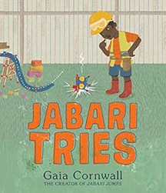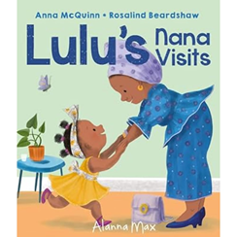  Key Books:  The Very Hungry Caterpillar by Eric Carle  Jabari Tries by Gaia Cornwall  Lulu’s Nana Visits by Anna McQuinn  Information books about autumn & families  The children will listen to and discuss these stories, enhancing their understanding through activities like retelling and role play. We will talk about how the characters in our stories feel. We will be enjoying rhymes, poems and stories every day!  Phonics  We will learn Set 1 letter sounds: m, a, s, d, t, i, n, p, g, o, c, k, u, b, f, e, l, h, r, j, v, y, w, z, x, sh, th, ch, qu, ng, nk. We will introduce blending these sounds with Fred the frog to read words, eg c-a-t, read as cat.  The children will be learning to hold a pencil correctly and practising writing letters to secure correct letter formation.  All of this work on writing will be underpinned by lots of activities to develop both their gross motor skills and their fine motor control. We would love for you to send in any drawing or writing from home to share. | Mathematics  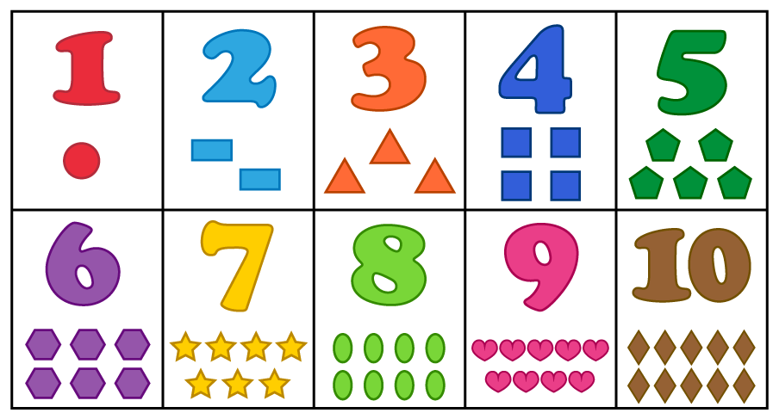  Number  During the first half of the Autumn term, the children will focus on exploring number throughout their play, to help develop a deep understanding.  Children should begin to recognise, read and write numbers 1-10. They will be encouraged to develop their 1 to 1 correspondence when counting, to count out sets of objects carefully, and also to match quantities to the appropriate numeral. They will begin to be able to talk about which set has more and which set has less. They will learn to ‘subitise’, or to recognise a small number of objects without having to count them.  Numerical patterns  Children will also start to use mathematical names for ‘solid’ 3D shapes and ‘flat’ 2D shapes, and mathematical terms to describe the shapes, such as a square having ‘4 straight sides and 4 corners’. | Understanding the World    Past & Present, and People, Culture & Communities  Children will talk about themselves and the things they like and dislike. They will also be encouraged to talk about their families and recognise similarities and differences in each other’s families. They will learn that we value every family.  Children will learn all about the celebration of harvest by learning songs and contributing towards our Harvest food collection.  The Natural World  We will explore the natural world, describing what we see, hear, and feel during outdoor activities like an Autumn walk. We will build vocabulary related to Autumn, naming and describing natural objects like conkers, acorns, rose hips, sycamore seeds, pine cones, and autumn leaves. We will develop observational skills by looking carefully at what we find. Children will draw pictures of their observations and incorporate natural autumnal objects in their mud kitchen play. We will be noticing all the kinds of weather we get in Autumn, and experiencing it all outside!
Key Vocabulary  Fiction, non-fiction, story, beginning, middle, end, phoneme, sound, blend | Key Vocabulary  Number names, subitise, count, more than, less than, altogether, bigger than, smaller than, circle, square, triangle, rectangle, straight, curve, corner | Key Vocabulary  Names of family members – eg sister, brother, cousin.  Days of the week, autumn, winter, spring, summer.  Conker, acorn, pine cone, sycamore seed, leaf, red, yellow, orange, brown.

Personal, Social and Emotional Development    Through our Jigsaw curriculum, children will develop their turn-taking skills, and increasingly learn to share with others. We will discuss significant adults in our lives and explore different feelings. The children will become familiar with the rules, signals, and routines both in the classroom and the outdoor environment. They will also understand the importance of caring for resources and tidying up after themselves.  This half term, our Jigsaw theme is ‘Being Me In My World’. | Communication and Language  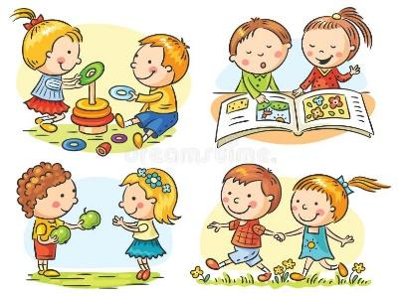  We will model speaking in full sentences, and will encourage the children to do the same. They will learn the importance of listening and responding to others, especially when they are being ‘talk partners’. We will support the children in using social phrases, such as ‘Good morning,’ and we will be building vocabulary through experiences.  We will also be enjoying a variety of rhymes, poems and songs, including learning some songs for our Harvest assembly. | Physical Development  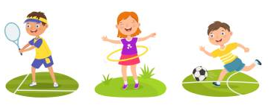  Children will be developing the skills needed to manage the school day successfully, such as learning the routines for lining up and queuing for lunch. They will begin to manage their lunch tray independently, with support if necessary. The children will experiment with different ways of moving and will show increasing control over one-handed tools like pencils, scissors, and paint brushes. They will also focus on gross motor skills, such as throwing and catching a ball. The children will start to secure a tripod grip when holding a pencil, with the reminder to ‘pinch, pinch, pinch your pencil’. We will encourage the children to use cutlery at lunchtime and to pour their own milk at the snack table, with support as needed. | Expressive Arts and Design    The children will have a wide variety of opportunities for mark making, both large and small scale. They will be able to investigate collage, chalks, painting and printing. They will also be able to construct using various materials, such as our wooden blocks, tyres and crates, Lego and Mobilo, and empty boxes and yogurt pots.  Therefore, we kindly request ongoing donations of junk modelling materials (clean pots, boxes, etc.) to be brought into school. Thank you!  Please make sure no donated boxes have contained nut products.

Here are some suggestions of the kind of books you may wish to read with your child to support their learning this term: | Here are some suggestions of how you can help with your child’s learning this half term:
- Traditional tales like Goldilocks and the Three Bears; The Three Little Pigs; Stone Soup, or The Enormous Turnip  - Books with stories about families  - Books with stories about friends  - Books with a strong rhythm and rhyme eg Elephant Wellyphant by Nick Sharratt, or rhyming books by Julia Donaldson  - Books your children love – it really doesn’t matter if they keep requesting an old favourite! | - Practise their Read, Write Inc Phonics sounds with them as often as you can  - Visit the library - sign your child up as a member if they are not already.  - Share the library book your child brings home from school each week – finding a short time for a bedtime story, or a story at any time, is so beneficial for your child.  - Go out to collect acorns, conkers, pine cones or sycamore seeds (we would love you to bring some to school!)  - Go on a leaf hunt to the local park/ woods - which colours can you see?  - Play with construction toys like Lego, or squishy materials like playdough, pastry or plasticene (all developing finger strength and dexterity)  - If you have a garden or outdoor space, could you plant some bulbs together, ready for the Spring?  - What shapes, colours and numbers can you spot on your walk to school?  - Take the opportunity to count as you are doing things – eg steps as you climb the stairs, cutlery, food items

